**HEALTH CARE MANAGEMENT**

PRODUCT NAME :

LIST OF SIMILAR PRODUCTS :

|  |  |  |
| --- | --- | --- |
| PRODUCT NAME | FEATURES | URL |
| Health soft | Doctor panel,patient tracking,analytics | https://www.healthsoft.com |

AMUTHA M

[927623BAD006@mkce.ac.in](mailto:927623BAD006@mkce.ac.in,amuthamurugesan111@gmail.com)

[amuthamurugesan111@gmail.com](mailto:927623BAD006@mkce.ac.in,amuthamurugesan111@gmail.com)

6383495168

**CONTRIBUTION**

Form normalization

Form design

Connecting to data base

Reports

Schema design

Sites.google.com

Portfolio

Git hub

Leetcode

<https://github.com/Amuthasince-2005/Amutha>

Patient_id - primary key

Appointment_id - foreign key

Doctor_id - foreign key

REPORT

Total_patient

Appointment date

Bill generation

Doctors on duty

CREATE TABLE Patients ()

Insert_table()

Create view()

Keywords

Attribute

Relation

Tuple

domain

Normalization

INF

My table is 1NF because it has a primary key name - patient_id

2NF

My table is 2NF because it has a primary key(patient_id) all other columns are depend on the primary key

3NF

Should be in 2NF no transitive partial dependencies

Eg student_id,name,job_id,job_name,state_id,state_name,

927623BAD006,AMUTHA M ,J_0106,Software Engineer,63536,Thoothukudi

1NF - student_id,student_name

2NF-student_roll,student_id,job_id

Student Info table- student_id,student_name ,state_id

Job_table,job_name

3NF-student_rolltable,Student_id,student_name,state_id

JOB INFO TABLE - Job_id,job_name

State_id,state_name

FRONT-END(html,css,javascript,react js,tailwin css,flask,android,flutter)

BACK-END(mysql,oracle,mongoDB,JSON,sqllight,fire base)

SERVER( vs code,xam)

FRAMEWORK(node JS)

LANGUAGE(python)

UNIT 5

XML

Eg:

Table (tag) - parent tag

Column name - separate with column

<XML>

<STUDENTINFO>

<ROLLNO> 12 </ROLLNO>

<NAME> RAMESH </NAME>

<AGE> 12 </AGE>

</XML>

<DOCTORINFO>

<DOCTORID>101</DOCTORID>

<NAME>Dr. Meena</NAME>

<SPECIALTY>Cardiology</SPECIALTY>

</DOCTORINFO>

<PATIENTINFO>

<PATIENTID>1</PATIENTID>

<NAME>Rahul</NAME>

<AGE>30</AGE>

<GENDER>Male</GENDER>

</PATIENTINFO>

DTD

<!DOCTYPE db[

<!ELEMENT db (person*)>

<!ELEMENT PATIENTINFO (PATIENTID, NAME, AGE, GENDER)>

<!ELEMENT PATIENTID (#PCDATA)>

<!ELEMENT NAME (#PCDATA)>

<!ELEMENT AGE (#PCDATA)>

<!ELEMENT GENDER (#PCDATA)>

]>

DTD with no elements:

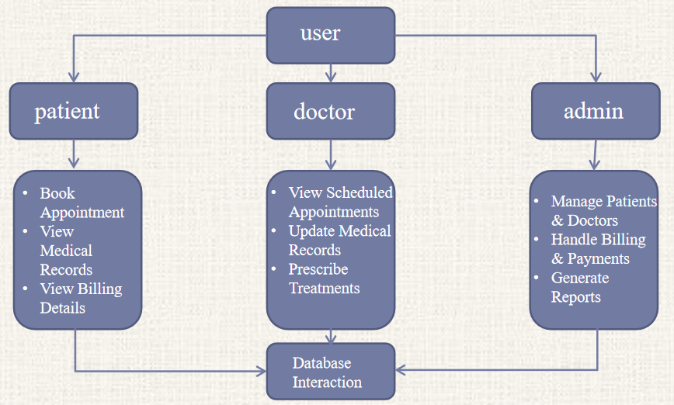

DTD with no elements:

(XML)

<login timeout = “100”></login>

DTD

<ELEMENT login EMPTY>

<!ATTLIST element login CDATA”0”>

JOIN

Left join

SELECT Patients.name, Appointments.appointment_date

FROM Patients

LEFT JOIN Appointments

ON Patients.patient_id = Appointments.patient_id;

Right join

SELECT Patients.name, Appointments.appointment_date

FROM Patients

RIGHT JOIN Appointments

ON Patients.patient_id = Appointments.patient_id;

Outer join

SELECT Patients.name, Appointments.appointment_date

FROM Patients

FULL OUTER JOIN Appointments

ON Patients.patient_id = Appointments.patient_id;

Inner join

SELECT Patients.name, Appointments.appointment_date

FROM Patients

INNER JOIN Appointments

ON Patients.patient_id = Appointments.patient_id;

MODULE DETAILS

|  |  |  |
| --- | --- | --- |
| MODULE NAME | SUBMODULE NAME | DESCRIPTION |
| Patient Management | Add Patient  View/Edit Patient  Delete Patient | Register new patients with basic details.  View and update existing patient records.  Remove patient records from the system. |

FORM DETAILS

|  |  |  |  |  |
| --- | --- | --- | --- | --- |
| MODULE NAME | FORM NAME TYPE | FORM DESCRIPTION | TABLE NAME TYPE | TABLE DESCRIPTION |
| ORDER_BOOK | BOOK ORDER FORM-TRANSACTION | I CAN SEE THE MENU,BOOK FOR THE ORDER | ORDER TABLE -TRANSACTION |  |

|  |  |  |  |  |
| --- | --- | --- | --- | --- |
| MODULE NAME | FORM NAME TYPE | FORM DESCRIPTION | TABLE NAME TYPE | TABLE DESCRIPTION |
| PATIENT_MANAGEMENT | PATIENT REGISTRATION FORM - TRANSACTION | Used to register a new patient | PATIENTS TABLE | TRANSACTION |

REPORTS

SCHEMA DESIGN